## 

## File Clerk Assessment

This role requires you to have good knowledge with Google Drive and English. Hence this assessment will test your ability to move different files around given the name of the file.

You will notice that in this assessment folder, we have 2 other folders:

* ‘Contour Database’
* ‘Files to Move’

All the files in the ‘Files to Move’ folder need to be put into their respective folders in the ‘Contour Database’ Folder, but need to be renamed accordingly.

First **Download the entire ‘File Clerk Assessment’ Folder.** Follow the instructions after.

## Instructions

You will notice that each file inside the ‘Files to Move’ folder has this naming structure:

*e.g. PS34 [1.8] - Example Psych 101 - Workbook*

Which means: *Subject [X.Y] - Topic - Resource Type*

### Step 1 - Moving Files

Move every file from ‘Files to Move’ folder into the correct folder inside the ‘Contour Database’ Folder - depending on this criteria below (You can do this for each file):

Subject

PS34 = Psychology Folder

MM34 = Methods Folder

CH34 = Chemistry Folder

PH34 = Physics Folder

**[X.Y]**

**Or X = 1, 2 or 3**

* Unit 3 Folder.

**Or X = 4, 5 or 6**

* Unit 4 Folder.

**Or X = 7**

* Exam Revision Folder.

**Example:**

Im going to move this selected file.

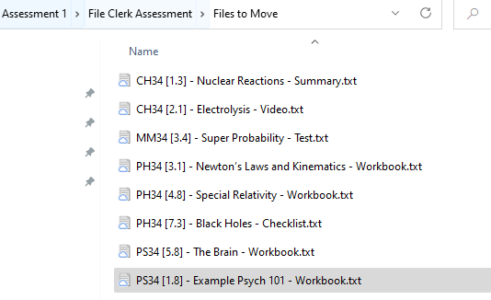

Since it is PS34 - it belongs in ‘Psychology’ folder

Since it is also says 1.8, it belongs in ‘Unit 3’ Folder. **Note: do not delete any of the other folders inside the subjects.**

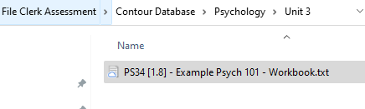

### Step 2 - Changing File Name

If the *Resource Type* is not ‘Video’, then each file must be renamed as:

*[X.Y] - Topic*

*Example:*

*[1.8] - Example Psych 101*

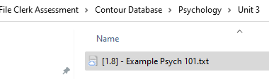

*__________________________________________________________________*

If the *Resource Type* **is a ‘Video’**, then the file must be renamed as:

**[LOCATION] SUBJECT - DAY (TIME) - [X.Y] Recording**

*Example:*

*[315013270B] Physics - Thursday (415 PM - 615 PM) - [1.2] Recording*

If the file name says ‘Video’, you will find the **[LOCATION], DAY and (TIME) inside the file.**

## After you finish

Once you have finished moving and changing the file names, you need to upload your updated ‘Contour Database’ Folder onto a file sharing tool like Google Drive or Dropbox. Once you have finished uploading, make sure the folder is open access and copy the shareable link across to the answer input.